Assignment 4:  
Ubuntu Web Server

*Kyle Walker*

*NETW2500*

*11/05/2024*

Table of Contents

Introduction 2

Task 1: 2

# Task 1: Install your Ubuntu Web Server

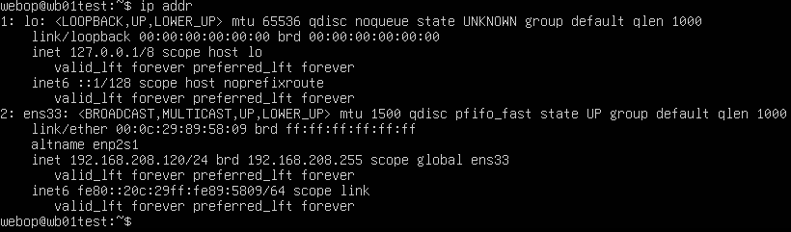

*IP Configuration for new Web Server*

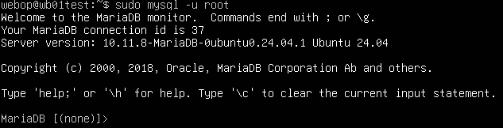

*Initial MariaDB Information*

*Info.php Details*

*“apacheuser” in “apachegroup”*

**

*“apacheuser” location in /etc/passwd/*

**

*“apachegroup” in /etc/group*

# Task 2: Install phpMyAdmin

## Part 1: Create a Database and Table

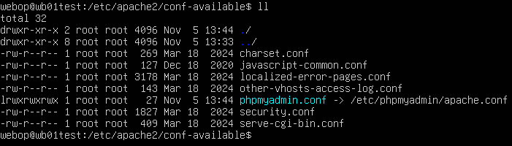

*PhpMyAdmin.conf symlink*

## Part 2: Use PHP Scripts to Manage Authentication

*A “cp -a -r” command copies the entire directory plus subdirectories and hidden files.*

*An “ll” command in the destination directory shows all permissions and subdirectories carried over*

# Task 4: Install WordPress and Create a Blog Page

*“wpmgr” SQL privileges*

# Documentation and Backups:

*Web Server Gold Copy Properties*

*Snapshots. Made sure to include the wild ride this Assignment took me on :P*